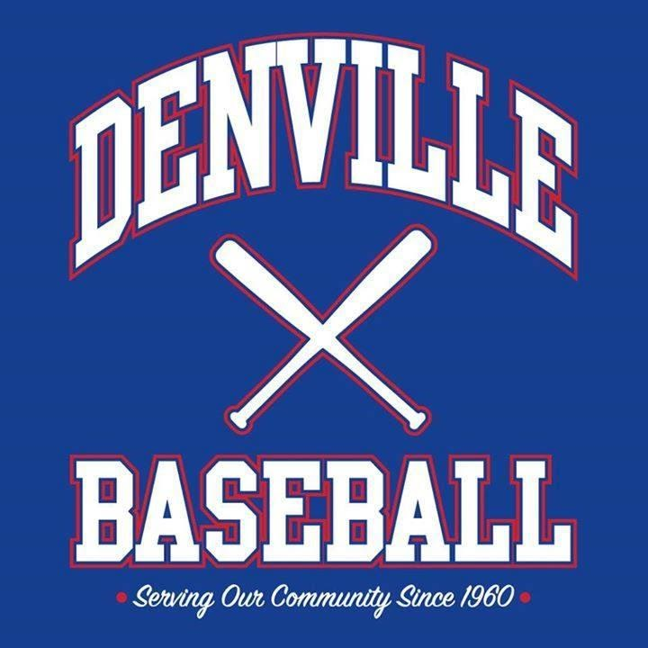
Please Make Checks Payable to:
“Denville Baseball” and Mail to:
Denville Baseball
10 Lafayette Place, Denville, NJ 07834

Questions? Email:
denvillebaseballpresident@gmail.com
or
denvillebaseballsecretary@gmail.com

2022 Sponsor Form
Business Name: ___________________________________________________________________
Contact Name: ____________________________________________________________________
Contact Phone:____________________ Contact E-mail:___________________________________ Address: _________________________________________________________________________ Website URL or Facebook page: _____________________________________________________
Business / Organization name to appear on Uniform (Please try to limit to 25 Characters): ________________________________________________________________________________
Uniform color request (no guarantees): ________________________________________________
League Request (no guarantees): • T-ball • Rookie • Minors • Majors
Do you have family playing in our program? • Yes • No
If so, player’s name and current school grade: ___________________________________________
• Team Sponsor (Company name on uniform) $300
(Includes name and hyperlink on Denville Baseball website)
Other Sponsor opportunities:
- Website only (name and hyperlink) $50
- Featured Sponsor (Website Banner /hyperlink (please provide image)) $100
- On Field Banner (all day Saturdays) – New Sponsor Banner $175
- On Field Banner (all day Saturdays) – re-up existing banner $50
- Other (please reach out to discuss other ideas you may have)
______________________________________________________________________

Denville Baseball 2022

